

Лабораторная работа №15
Тема: Триггеры в WPF-приложениях.
По дисциплине: Разработка программных модулей

Выполнил: студент группы ИС-24
Пашина Валентина

г. Улан-Удэ
2026 г.
Главная форма
Листинг кода:
<Window x:Class="LR15.MainWindow"
xmlns="http://schemas.microsoft.com/winfx/2006/xaml/presentation"
xmlns:x="http://schemas.microsoft.com/winfx/2006/xaml"
Title="Лабораторная работа №15 - Триггеры в WPF"
Height="600" Width="800"
WindowStartupLocation="CenterScreen">
<Grid Background="#F0F0F0">
<ScrollViewer VerticalScrollBarVisibility="Auto" Margin="0,0,0,114">
<StackPanel Margin="20">
<TextBlock FontSize="24" FontWeight="Bold" Foreground="#333"
Text="Лабораторная работа №15" HorizontalAlignment="Center" Margin="0,10,0,5"/>
<TextBlock FontSize="16" Foreground="#666"
Text="Триггеры в WPF" HorizontalAlignment="Center" Margin="0,0,0,20"/>
<Border Background="White" BorderBrush="#CCC" BorderThickness="1" CornerRadius="5" Padding="10" Margin="0,0,0,15" Width="704">
<StackPanel>
<TextBlock FontSize="16" FontWeight="Bold" Text="Примеры" Margin="0,0,0,10"/>
<WrapPanel>
<Button x:Name="btnPrimer1" Content="Пример 1 - Простой триггер"
Width="200" Height="35" Margin="5" Background="#9B59B6" Foreground="White" Click="btnPrimer1_Click"/>
<Button x:Name="btnPrimer2" Content="Пример 2 - DataTrigger"
Width="200" Height="35" Margin="5" Background="#9B59B6" Foreground="White" Click="btnPrimer2_Click"/>
</WrapPanel>
</StackPanel>
</Border>
<Border Background="White" BorderBrush="#CCC" BorderThickness="1" CornerRadius="5" Padding="10" Margin="0,0,0,15" Width="708">
<StackPanel>
<TextBlock FontSize="16" FontWeight="Bold" Text="Задания" Margin="0,0,0,10"/>
<WrapPanel>
<Button x:Name="btnZadanie1" Content="Задание 1"
Width="150" Height="35" Margin="5" Background="#3498DB" Foreground="White" Click="btnZadanie1_Click"/>
<Button x:Name="btnZadanie2" Content="Задание 2"
Width="150" Height="35" Margin="5" Background="#3498DB" Foreground="White" Click="btnZadanie2_Click"/>
<Button x:Name="btnZadanie3" Content="Задание 3"
Width="150" Height="35" Margin="5" Background="#3498DB" Foreground="White" Click="btnZadanie3_Click"/>
<Button x:Name="btnZadanie4" Content="Задание 4"
Width="150" Height="35" Margin="5" Background="#3498DB" Foreground="White" Click="btnZadanie4_Click"/>
<Button x:Name="btnZadanie5" Content="Задание 5"
Width="150" Height="35" Margin="5" Background="#3498DB" Foreground="White" Click="btnZadanie5_Click"/>
</WrapPanel>
</StackPanel>
</Border>
</StackPanel>
</ScrollViewer>
</Grid>
</Window>
Код cs:
using System.Windows;

namespace LR15
{
/// <summary>
/// Логика взаимодействия для MainWindow.xaml
/// </summary>
public partial class MainWindow : Window
{
public MainWindow()
{
InitializeComponent();
}
private void btnPrimer1_Click(object sender, RoutedEventArgs e)
{
primer1 window = new primer1();
window.ShowDialog();
}
private void btnPrimer2_Click(object sender, RoutedEventArgs e)
{
primer2 window = new primer2();
window.ShowDialog();
}
private void btnZadanie1_Click(object sender, RoutedEventArgs e)
{
zadanie1 window = new zadanie1();
window.ShowDialog();
}
private void btnZadanie2_Click(object sender, RoutedEventArgs e)
{
zadanie2 window = new zadanie2();
window.ShowDialog();
}
private void btnZadanie3_Click(object sender, RoutedEventArgs e)
{
zadanie3 window = new zadanie3();
window.ShowDialog();
}
private void btnZadanie4_Click(object sender, RoutedEventArgs e)
{
zadanie4 window = new zadanie4();
window.ShowDialog();
}
private void btnZadanie5_Click(object sender, RoutedEventArgs e)
{
zadanie5 window = new zadanie5();
window.ShowDialog();
}
}
}
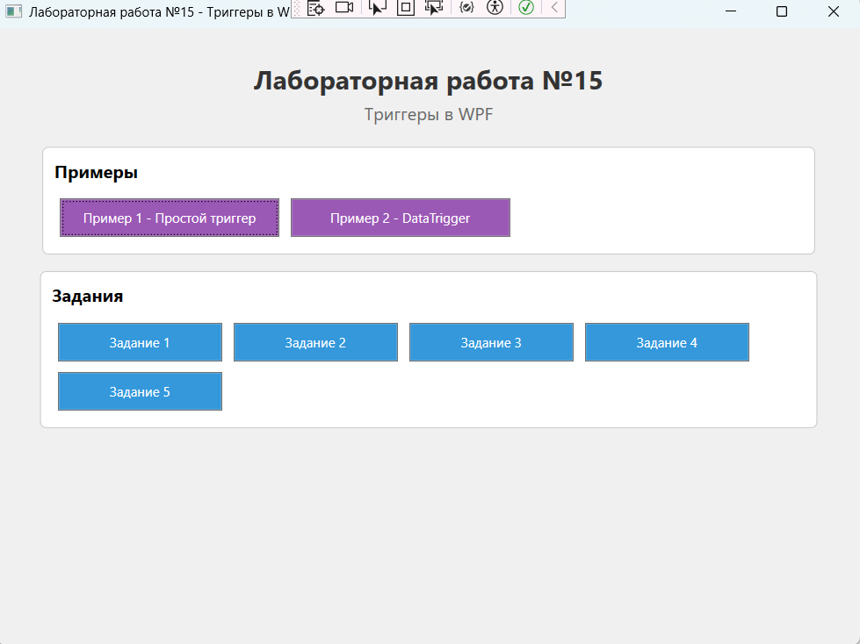
Рис. 1 «Результат»
Пример 1
Листинг кода:
<Window x:Class="LR15.primer1"
xmlns="http://schemas.microsoft.com/winfx/2006/xaml/presentation"
xmlns:x="http://schemas.microsoft.com/winfx/2006/xaml"
Title="Пример 1 - Простой триггер"
Height="200" Width="500"
WindowStartupLocation="CenterOwner">
<Window.Resources>
<Style TargetType="Button">
<Style.Triggers>
<Trigger Property="IsMouseOver" Value="True">
<Trigger.Setters>
<Setter Property="FontSize" Value="20" />
</Trigger.Setters>
</Trigger>
</Style.Triggers>
</Style>
</Window.Resources>
<StackPanel Orientation="Horizontal" VerticalAlignment="Top" Margin="20">
<Button>Открыть</Button>
<Button>Обработать</Button>
<Button>Сохранить</Button>
<Button>Закрыть</Button>
</StackPanel>
</Window>
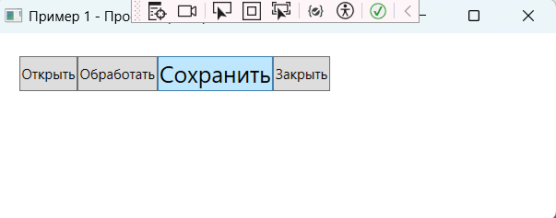
Рис. 2 «Результат»

Пример 2
Листинг кода:
<Window x:Class="LR15.primer2"
xmlns="http://schemas.microsoft.com/winfx/2006/xaml/presentation"
xmlns:x="http://schemas.microsoft.com/winfx/2006/xaml"
Title="Пример 2 - DataTrigger"
Height="200" Width="500"
WindowStartupLocation="CenterOwner">
<Window.Resources>
<Style TargetType="Button">
<Style.Triggers>
<DataTrigger Binding="{Binding ElementName=slider1, Path=Value}" Value="0">
<Setter Property="IsEnabled" Value="False"></Setter>
</DataTrigger>
</Style.Triggers>
</Style>
</Window.Resources>
<StackPanel Orientation="Horizontal" VerticalAlignment="Top" Margin="20">
<Button>Открыть</Button>
<Button>Обработать</Button>
<Slider Height="23" x:Name="slider1" Width="100" />
<Button>Закрыть</Button>
</StackPanel>
</Window>
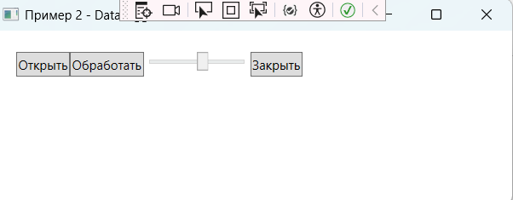
Рис. 3 «Результат»
Задание 1
Листинг кода:
<Window x:Class="LR15.zadanie1"
xmlns="http://schemas.microsoft.com/winfx/2006/xaml/presentation"
xmlns:x="http://schemas.microsoft.com/winfx/2006/xaml"
Title="Задание 1 - Изменение внешнего вида с триггерами"
Height="702" Width="858"
WindowStartupLocation="CenterOwner">
<Window.Resources>
<Style x:Key="SimpleButtonStyle" TargetType="Button">
<Setter Property="Background" Value="#3498DB"/>
<Setter Property="Foreground" Value="White"/>
<Setter Property="FontSize" Value="16"/>
<Setter Property="Width" Value="200"/>
<Setter Property="Height" Value="50"/>
<Setter Property="Margin" Value="10"/>
<Setter Property="Cursor" Value="Hand"/>
<Style.Triggers>
<Trigger Property="IsMouseOver" Value="True">
<Setter Property="Background" Value="#E74C3C"/>
<Setter Property="Foreground" Value="White"/>
</Trigger>
<Trigger Property="IsPressed" Value="True">
<Setter Property="Background" Value="#C0392B"/>
</Trigger>
</Style.Triggers>
</Style>
</Window.Resources>
<Grid Background="#F0F0F0" Margin="0,0,0,-104">
<Grid.ColumnDefinitions>
<ColumnDefinition Width="71*"/>
<ColumnDefinition Width="358*"/>
</Grid.ColumnDefinitions>
<Grid.RowDefinitions>
<RowDefinition Height="365*"/>
<RowDefinition Height="411*"/>
</Grid.RowDefinitions>
<StackPanel Margin="78,10,0,79" HorizontalAlignment="Left" Width="702" Grid.RowSpan="2" Grid.ColumnSpan="2">
<TextBlock FontSize="22" FontWeight="Bold" Foreground="#2C3E50"
Text="Задание 1: Изменение внешнего вида с триггерами"
HorizontalAlignment="Center" Margin="0,10,0,20"/>
<Border Background="White" BorderBrush="#CCC" BorderThickness="1" CornerRadius="10" Padding="15" Margin="0,10" Width="688" Height="257">
<StackPanel>
<TextBlock FontSize="16" FontWeight="Bold" Foreground="#2980B9"
Text="Кнопки с триггерами:" Margin="0,0,0,10"/>
<WrapPanel HorizontalAlignment="Center">
<Button Style="{StaticResource SimpleButtonStyle}" Content="Наведи на меня"/>
<Button Style="{StaticResource SimpleButtonStyle}" Content="Нажми на меня"/>
<Button Style="{StaticResource SimpleButtonStyle}" Content="Обычная кнопка"/>
</WrapPanel>
</StackPanel>
</Border>
<Border Background="White" BorderBrush="#CCC" BorderThickness="1" CornerRadius="10" Padding="15" Margin="0,10" Width="686" Height="246">
<StackPanel Width="668">
<TextBlock FontSize="16" FontWeight="Bold" Foreground="#2980B9"
Text="Текстовые поля с валидацией:" Margin="0,0,0,10"/>
<StackPanel Orientation="Horizontal" HorizontalAlignment="Center">
<StackPanel>
<TextBlock Text="Email:" Margin="10,10,10,0" FontWeight="Bold"/>
<TextBox x:Name="txtEmail" Width="250" Height="40"
Margin="10" Padding="10" FontSize="14"
TextChanged="txtEmail_TextChanged"/>
</StackPanel>
<StackPanel>
<TextBlock Text="Пароль:" Margin="10,10,10,0" FontWeight="Bold"/>
<TextBox x:Name="txtPassword" Width="250" Height="40"
Margin="10" Padding="10" FontSize="14"
TextChanged="txtPassword_TextChanged"/>
</StackPanel>
</StackPanel>
<TextBlock x:Name="lblEmailStatus" Text="Ожидание ввода email..."
Foreground="Gray" Margin="10,10,0,0"/>
<TextBlock x:Name="lblPasswordStatus" Text="Ожидание ввода пароля..."
Foreground="Gray" Margin="10,5,0,0"/>
</StackPanel>
</Border>
</StackPanel>
</Grid>
</Window>

Код cs:
using System.Text.RegularExpressions;
using System.Windows;
using System.Windows.Media;

namespace LR15
{
public partial class zadanie1 : Window
{
public zadanie1()
{
InitializeComponent();
}
private void txtEmail_TextChanged(object sender, System.Windows.Controls.TextChangedEventArgs e)
{
string email = txtEmail.Text;
bool isValid = IsValidEmail(email);

if (string.IsNullOrEmpty(email))
{
txtEmail.Background = Brushes.LightPink;
lblEmailStatus.Text = "Email не может быть пустым";
lblEmailStatus.Foreground = Brushes.Red;
}
else if (isValid)
{
txtEmail.Background = Brushes.LightGreen;
lblEmailStatus.Text = "Email корректный";
lblEmailStatus.Foreground = Brushes.Green;
}
else
{
txtEmail.Background = Brushes.LightCoral;
lblEmailStatus.Text = "Неверный формат email (должен содержать @ и .)";
lblEmailStatus.Foreground = Brushes.Red;
}
}
private void txtPassword_TextChanged(object sender, System.Windows.Controls.TextChangedEventArgs e)
{
string password = txtPassword.Text;
if (string.IsNullOrEmpty(password))
{
txtPassword.Background = Brushes.LightPink;
lblPasswordStatus.Text = "Пароль не может быть пустым";
lblPasswordStatus.Foreground = Brushes.Red;
}
else if (password.Length >= 6)
{
txtPassword.Background = Brushes.LightGreen;
lblPasswordStatus.Text = "Пароль надежный (6+ символов)";
lblPasswordStatus.Foreground = Brushes.Green;
}
else
{
txtPassword.Background = Brushes.LightCoral;
lblPasswordStatus.Text = "Пароль слишком короткий (минимум 6 символов)";
lblPasswordStatus.Foreground = Brushes.Red;
}
}
private bool IsValidEmail(string email)
{
if (string.IsNullOrEmpty(email)) return false;
try
{
return Regex.IsMatch(email, @"^[^@\s]+@[^@\s]+\.[^@\s]+$");
}
catch
{
return false;
}
}
}
}
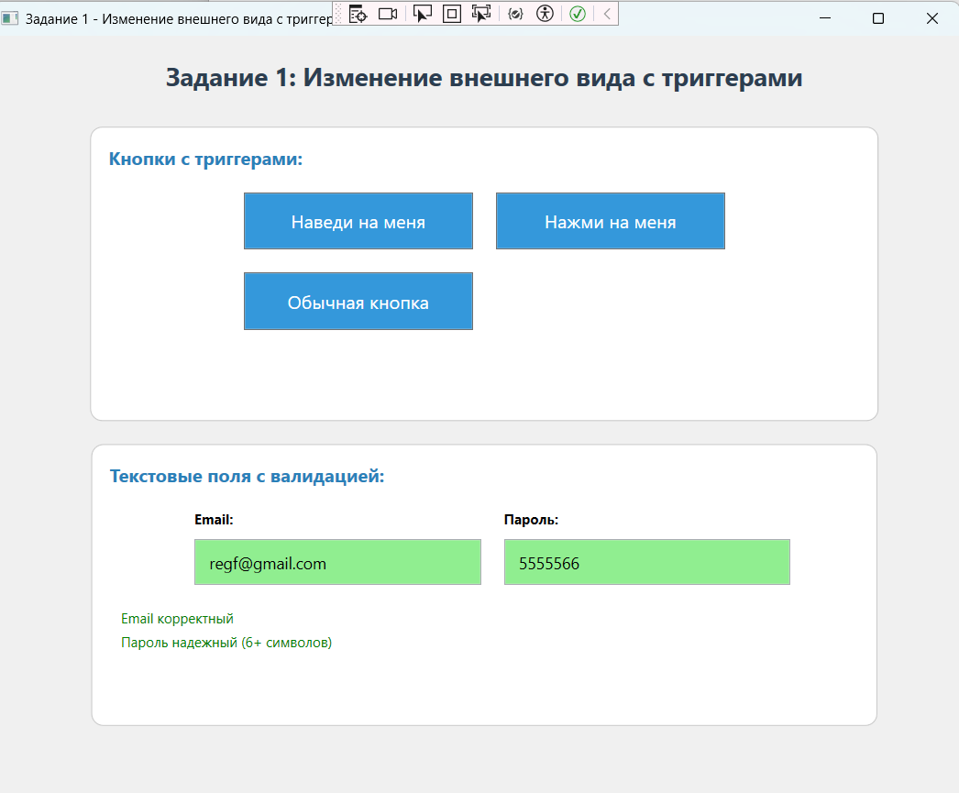
Рис. 4 «Результат»

Задание 2
Листинг кода:
<Window x:Class="LR15.zadanie2"
xmlns="http://schemas.microsoft.com/winfx/2006/xaml/presentation"
xmlns:x="http://schemas.microsoft.com/winfx/2006/xaml"
Title="Задание 2 - Стили и шаблоны с триггерами"
Height="384" Width="613"
WindowStartupLocation="CenterOwner">
<Window.Resources>
<Style x:Key="MyButtonStyle" TargetType="Button">
<Setter Property="Background" Value="#3498DB"/>
<Setter Property="Foreground" Value="White"/>
<Setter Property="FontSize" Value="16"/>
<Setter Property="Width" Value="180"/>
<Setter Property="Height" Value="50"/>
<Setter Property="Margin" Value="10"/>
<Setter Property="Cursor" Value="Hand"/>
<Style.Triggers>
<Trigger Property="IsMouseOver" Value="True">
<Setter Property="Background" Value="#E74C3C"/>
<Setter Property="FontSize" Value="18"/>
</Trigger>
<Trigger Property="IsPressed" Value="True">
<Setter Property="Background" Value="#C0392B"/>
</Trigger>
<Trigger Property="IsEnabled" Value="False">
<Setter Property="Background" Value="#95A5A6"/>
<Setter Property="Cursor" Value="Arrow"/>
</Trigger>
</Style.Triggers>
</Style>
</Window.Resources>
<Grid Background="#F0F0F0">
<StackPanel HorizontalAlignment="Center" VerticalAlignment="Center">
<TextBlock FontSize="20" FontWeight="Bold" Foreground="#2C3E50"
Text="Задание 2: Стили и шаблоны с триггерами"
Margin="0,0,0,30"/>
<WrapPanel HorizontalAlignment="Center" Height="137">
<Button Style="{StaticResource MyButtonStyle}" Content="Сохранить"/>
<Button Style="{StaticResource MyButtonStyle}" Content="Редактировать"/>
<Button Style="{StaticResource MyButtonStyle}" Content="Удалить"/>
<Button Style="{StaticResource MyButtonStyle}" Content="Отключена" IsEnabled="False"/>
</WrapPanel>
</StackPanel>
</Grid>
</Window>
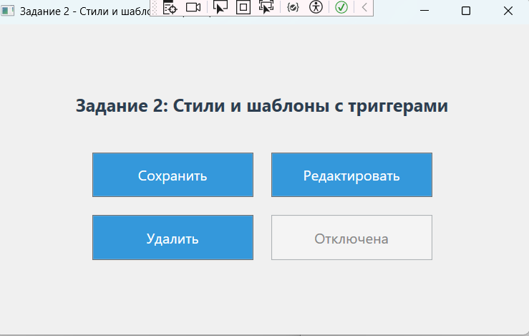
Рис. 5 «Результат»

Задание 3
Листинг кода:
<Window x:Class="LR15.zadanie3"
xmlns="http://schemas.microsoft.com/winfx/2006/xaml/presentation"
xmlns:x="http://schemas.microsoft.com/winfx/2006/xaml"
Title="Задание 3 - Анимация переходов"
Height="400" Width="600"
WindowStartupLocation="CenterOwner">
<Window.Resources>
<Storyboard x:Key="FadeInAnimation">
<DoubleAnimation Storyboard.TargetProperty="Opacity"
From="0" To="1" Duration="0:0:0.5"/>
</Storyboard>
</Window.Resources>
<Grid Background="#F0F0F0">
<StackPanel HorizontalAlignment="Center" VerticalAlignment="Center">
<TextBlock FontSize="20" FontWeight="Bold" Foreground="#2C3E50"
Text="Задание 3: Анимация переходов"
Margin="0,0,0,20"/>
<TextBlock Text="При загрузке окна - плавное появление"
Foreground="Gray" Margin="0,0,0,30"/>
<Border x:Name="ContentBorder" Background="#3498DB"
CornerRadius="10" Padding="40" Margin="10">
<TextBlock Text="Анимированный контент"
Foreground="White" FontSize="18" FontWeight="Bold"/>
</Border>
</StackPanel>
</Grid>
</Window>
Код cs:
using System.Windows;
using System.Windows.Media.Animation;

namespace LR15
{
public partial class zadanie3 : Window
{
public zadanie3()
{
InitializeComponent();
this.Loaded += Window_Loaded;
}
private void Window_Loaded(object sender, RoutedEventArgs e)
{
Storyboard storyboard = this.Resources["FadeInAnimation"] as Storyboard;
if (storyboard != null)
{
Storyboard.SetTarget(storyboard, ContentBorder);
storyboard.Begin();
}
}
}
}
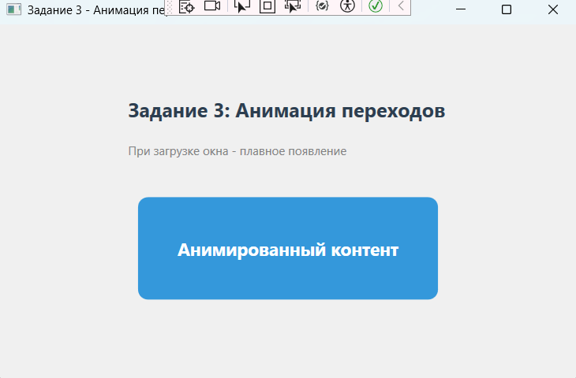
Рис. 6 «Результат»

Задание 4
Листинг кода:
<Window x:Class="LR15.zadanie4"
xmlns="http://schemas.microsoft.com/winfx/2006/xaml/presentation"
xmlns:x="http://schemas.microsoft.com/winfx/2006/xaml"
Title="Задание 4 - Триггеры для реакции на данные"
Height="603" Width="500"
WindowStartupLocation="CenterOwner">
<Grid Background="#F0F0F0" Margin="0,0,0,-16">
<Grid.RowDefinitions>
<RowDefinition Height="498*"/>
<RowDefinition Height="89*"/>
</Grid.RowDefinitions>
<StackPanel Margin="20,20,20,10" Grid.RowSpan="2">
<TextBlock FontSize="20" FontWeight="Bold" Foreground="#2C3E50"
Text="Задание 4: Список задач"
HorizontalAlignment="Center" Margin="0,0,0,20"/>
<ListBox x:Name="taskList" Height="230" Margin="0,10">
<ListBox.ItemTemplate>
<DataTemplate>
<StackPanel Orientation="Horizontal" Margin="5">
<CheckBox IsChecked="{Binding IsDone}" Width="30"
Click="CheckBox_Click"/>
<TextBlock Text="{Binding Title}" FontSize="14"
VerticalAlignment="Center"/>
</StackPanel>
</DataTemplate>
</ListBox.ItemTemplate>
</ListBox>
<Border Background="White" BorderBrush="#CCC" BorderThickness="1"
CornerRadius="5" Padding="10" Margin="0,10" Height="142">
<StackPanel>
<TextBlock FontWeight="Bold" Text="Статистика:"/>
<StackPanel Orientation="Horizontal" Margin="0,5">
<TextBlock Text="Всего задач:" Width="100"/>
<TextBlock x:Name="lblTotal" FontWeight="Bold"/>
</StackPanel>
<StackPanel Orientation="Horizontal" Margin="0,5">
<TextBlock Text="Выполнено:" Width="100"/>
<TextBlock x:Name="lblDone" Foreground="Green" FontWeight="Bold"/>
</StackPanel>
<StackPanel Orientation="Horizontal" Margin="0,5">
<TextBlock Text="Не выполнено:" Width="100"/>
<TextBlock x:Name="lblNotDone" Foreground="Red" FontWeight="Bold"/>
</StackPanel>
<ProgressBar x:Name="progressBar" Height="15" Margin="0,10"/>
</StackPanel>
</Border>
<StackPanel Orientation="Horizontal" Margin="0,10">
<TextBox x:Name="txtNewTask" Width="250" Height="30" Margin="0,0,5,0"/>
<Button x:Name="btnAdd" Content="Добавить" Width="80" Height="30"
Background="#3498DB" Foreground="White" Click="btnAdd_Click"/>
<Button x:Name="btnClear" Content="Очистить" Width="80" Height="30"
Background="#E74C3C" Foreground="White" Margin="5,0,0,0"
Click="btnClear_Click"/>
</StackPanel>
</StackPanel>
</Grid>
</Window>

Код cs:
using System.Collections.ObjectModel;
using System.ComponentModel;
using System.Linq;
using System.Windows;
using System.Windows.Controls;
namespace LR15
{
public partial class zadanie4 : Window
{
private ObservableCollection<Task> tasks;
public zadanie4()
{
InitializeComponent();
tasks = new ObservableCollection<Task>();
taskList.ItemsSource = tasks;
UpdateStats();
}
private void UpdateStats()
{
int total = tasks.Count;
int done = tasks.Count(t => t.IsDone);
int notDone = total - done;
lblTotal.Text = total.ToString();
lblDone.Text = done.ToString();
lblNotDone.Text = notDone.ToString();
progressBar.Value = total > 0 ? (double)done / total * 100 : 0;
}
private void CheckBox_Click(object sender, RoutedEventArgs e)
{
UpdateStats();
}
private void btnAdd_Click(object sender, RoutedEventArgs e)
{
if (!string.IsNullOrWhiteSpace(txtNewTask.Text))
{
tasks.Add(new Task { Title = txtNewTask.Text, IsDone = false });
txtNewTask.Text = "";
UpdateStats();
}
}
private void btnClear_Click(object sender, RoutedEventArgs e)
{
tasks.Clear();
UpdateStats();
}
}
public class Task : INotifyPropertyChanged
{
private string _title;
private bool _isDone;
public string Title
{
get => _title;
set { _title = value; OnPropertyChanged("Title"); }
}
public bool IsDone
{
get => _isDone;
set { _isDone = value; OnPropertyChanged("IsDone"); }
}
public event PropertyChangedEventHandler PropertyChanged;
protected void OnPropertyChanged(string name)
{
PropertyChanged?.Invoke(this, new PropertyChangedEventArgs(name));
}
}
}
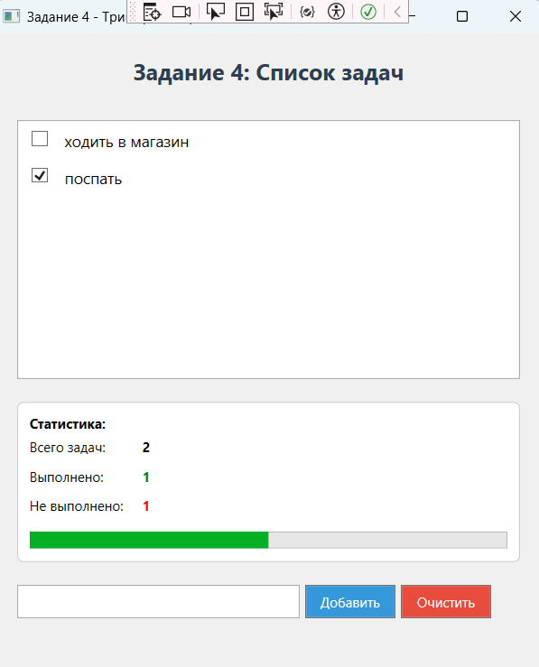
Рис. 6 «Результат»
Задание 5
Листинг кода:
<Window x:Class="LR15.zadanie5"
xmlns="http://schemas.microsoft.com/winfx/2006/xaml/presentation"
xmlns:x="http://schemas.microsoft.com/winfx/2006/xaml"
Title="Задание 5 - Текстовые поля с триггерами"
Height="395" Width="600"
WindowStartupLocation="CenterOwner">
<Window.Resources>
<Style x:Key="ActionButtonStyle" TargetType="Button">
<Setter Property="Background" Value="#3498DB"/>
<Setter Property="Foreground" Value="White"/>
<Setter Property="FontSize" Value="14"/>
<Setter Property="Width" Value="100"/>
<Setter Property="Height" Value="35"/>
<Setter Property="Margin" Value="5"/>
<Setter Property="Cursor" Value="Hand"/>
<Style.Triggers>
<Trigger Property="IsMouseOver" Value="True">
<Setter Property="Background" Value="#E74C3C"/>
</Trigger>
<Trigger Property="IsPressed" Value="True">
<Setter Property="Background" Value="#C0392B"/>
</Trigger>
</Style.Triggers>
</Style>
<Style x:Key="GradientTextBox" TargetType="TextBox">
<Setter Property="Height" Value="120"/>
<Setter Property="Width" Value="250"/>
<Setter Property="Margin" Value="10"/>
<Setter Property="Padding" Value="10"/>
<Setter Property="TextWrapping" Value="Wrap"/>
<Setter Property="AcceptsReturn" Value="True"/>
<Setter Property="VerticalScrollBarVisibility" Value="Auto"/>
</Style>
</Window.Resources>
<Grid Background="#F0F0F0" Height="385" VerticalAlignment="Top">
<StackPanel Margin="20">
<TextBlock FontSize="20" FontWeight="Bold" Foreground="#2C3E50"
Text="Задание 5: Текстовые поля с триггерами"
HorizontalAlignment="Center" Margin="0,0,0,20"/>

<StackPanel Orientation="Horizontal" HorizontalAlignment="Center" Margin="0,10">
<TextBlock Text="Стиль текста:" VerticalAlignment="Center" Margin="10"/>
<ComboBox x:Name="cmbStyle" Width="150" Height="30"
SelectionChanged="cmbStyle_SelectionChanged">
<ComboBoxItem Content="Обычный" IsSelected="True"/>
<ComboBoxItem Content="Крупный"/>
<ComboBoxItem Content="Маленький"/>
<ComboBoxItem Content="Красный"/>
<ComboBoxItem Content="Синий"/>
</ComboBox>
</StackPanel>
<StackPanel Orientation="Horizontal" HorizontalAlignment="Center">
<Border CornerRadius="10" Margin="10">
<Border.Background>
<LinearGradientBrush EndPoint="1,1" StartPoint="0,0">
<GradientStop Color="#E8EAF6" Offset="0"/>
<GradientStop Color="#F3E5F5" Offset="1"/>
</LinearGradientBrush>
</Border.Background>
<TextBox x:Name="txtBox1" Style="{StaticResource GradientTextBox}"/>
</Border>
<Border CornerRadius="10" Margin="10">
<Border.Background>
<LinearGradientBrush EndPoint="1,1" StartPoint="0,0">
<GradientStop Color="#E8EAF6" Offset="0"/>
<GradientStop Color="#F3E5F5" Offset="1"/>
</LinearGradientBrush>
</Border.Background>
<TextBox x:Name="txtBox2" Style="{StaticResource GradientTextBox}"/>
</Border>
</StackPanel>
<WrapPanel HorizontalAlignment="Center" Margin="10">
<Button x:Name="btnOpen" Style="{StaticResource ActionButtonStyle}"
Content="Открыть" Click="btnOpen_Click"/>
<Button x:Name="btnClear" Style="{StaticResource ActionButtonStyle}"
Content="Очистить" Click="btnClear_Click"/>
<Button x:Name="btnClose" Style="{StaticResource ActionButtonStyle}"
Content="Закрыть" Click="btnClose_Click"/>
</WrapPanel>
</StackPanel>
</Grid>
</Window>

Код cs:
using System.IO;
using System.Windows;
using System.Windows.Controls;
using System.Windows.Media;

namespace LR15
{
public partial class zadanie5 : Window
{
public zadanie5()
{
InitializeComponent();
UpdateCloseButton();
txtBox1.TextChanged += (s, e) => UpdateCloseButton();
txtBox2.TextChanged += (s, e) => UpdateCloseButton();
}
private void UpdateCloseButton()
{
bool bothEmpty = string.IsNullOrWhiteSpace(txtBox1.Text) &&
string.IsNullOrWhiteSpace(txtBox2.Text);
btnClose.IsEnabled = bothEmpty;
if (bothEmpty)
btnClose.Background = new SolidColorBrush((Color)ColorConverter.ConvertFromString("#2ECC71"));
else
btnClose.Background = new SolidColorBrush((Color)ColorConverter.ConvertFromString("#95A5A6"));
}
private void cmbStyle_SelectionChanged(object sender, SelectionChangedEventArgs e)
{
if (txtBox1 == null || txtBox2 == null) return;
ComboBoxItem item = cmbStyle.SelectedItem as ComboBoxItem;
if (item == null) return;
string style = item.Content.ToString();
txtBox1.FontSize = 14;
txtBox1.FontWeight = FontWeights.Normal;
txtBox1.Foreground = Brushes.Black;
txtBox2.FontSize = 14;
txtBox2.FontWeight = FontWeights.Normal;
txtBox2.Foreground = Brushes.Black;
switch (style)
{
case "Обычный":
break;
case "Крупный":
txtBox1.FontSize = 20;
txtBox1.FontWeight = FontWeights.Bold;
txtBox2.FontSize = 20;
txtBox2.FontWeight = FontWeights.Bold;
break;
case "Маленький":
txtBox1.FontSize = 10;
txtBox2.FontSize = 10;
break;
case "Красный":
txtBox1.Foreground = Brushes.Red;
txtBox2.Foreground = Brushes.Red;
break;
case "Синий":
txtBox1.Foreground = Brushes.Blue;
txtBox2.Foreground = Brushes.Blue;
break;
}
}
private void btnOpen_Click(object sender, RoutedEventArgs e)
{
Microsoft.Win32.OpenFileDialog dlg = new Microsoft.Win32.OpenFileDialog();
dlg.DefaultExt = ".txt";
dlg.Filter = "Text Files (*.txt)|*.txt|All Files (*.*)|*.*";

if (dlg.ShowDialog() == true)
{
string content = File.ReadAllText(dlg.FileName);
txtBox1.Text = content;
}
}
private void btnClear_Click(object sender, RoutedEventArgs e)
{
txtBox1.Text = "";
txtBox2.Text = "";
}
private void btnClose_Click(object sender, RoutedEventArgs e)
{
this.Close();
}
}
}
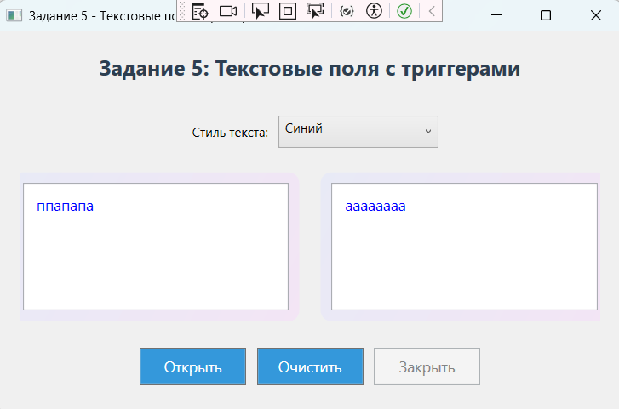
Рис. 7 «Результат»

Контрольные вопросы:
- Что такое Триггер в WPF?
- Какие триггеры есть WPF? Расскажите о них
Ответы:
- Триггер в WPF — это механизм, который позволяет автоматически изменять свойства элемента управления или запускать действия (например, анимацию) при выполнении определённых условий: изменении значения свойства, возникновении события или выполнении нескольких условий одновременно.
- Trigger
Отслеживает одно свойство элемента (например, IsMouseOver). При достижении заданного значения меняет стиль (через Setters).
Пример: изменить цвет кнопки при наведении курсора.
MultiTrigger
Срабатывает, если все указанные свойства элемента одновременно соответствуют условиям (логическое И).
Пример: применить стиль, когда кнопка в фокусе и на неё наведён курсор.
DataTrigger
Реагирует на значение привязанных данных (Binding), а не на свойства элемента.
Пример: подсветить поле красным, если Status == "Error".
MultiDataTrigger
Аналогичен MultiTrigger, но для данных. Срабатывает, когда все условия по данным выполняются одновременно.
Пример: выделить элемент, если Status == "Error" и Priority == "High".
EventTrigger
Запускает анимации (Storyboard) в ответ на события (например, MouseEnter, Click).
Пример: плавное изменение прозрачности при наведении.

